# VISVESVARAYA TECHNOLOGICAL UNIVERSITY BELGAUM - 590014



### A DBMS Mini-Project Report On

**“HOUSE RENTAL MANAGEMENT”**

*A Mini-project report submitted in partial fulfillment of the requirements for the award of the degree of* ***Bachelor of Engineering in Computer Science and Engineering***

*of Visvesvaraya Technological University, Belgaum.*

Submitted by:

**AISHWARYA.D (1DT18CS009)**

Under the Guidance of:

#### Dr. Sandhya N (Assoc. Prof. Dept of CSE)

**Department of Computer Science and Engineering**

**DAYANANDA SAGAR ACADEMY OF TECHNOLOGY AND**

**MANAGEMENT**

Kanakapura Road, Udayapura, Bangalore

2019-2020

(Accredited by NBA, New Delhi for 3 years validity: 26-07-2018 to 30-06-2021)

**DAYANANDA SAGAR ACADEMY OF TECHNOLOGY AND MANAGEMENT,**

Kanakapura Road, Udayapura, Bangalore

**DEPARTMENT OF COMPUTER SCIENCE & ENGINEERING**



**CERTIFICATE**

This is to certify that the Mini-Project on Database Management System (DBMS) entitled **“HOUSE RENTAL MANAGEMENT”** has been successfully carried out by **AISHWARYA.D (1DT18CS009) and CHANDRASHEKAR.G(1DT18CS031)** a bonafide students of **Dayananda sagar academy of technology and management** in partial fulfillment of the requirements for the award of degree in **Bachelor of Engineering in Computer Science and Engineering** of **Visvesvaraya Technological University, Belgaum** during academic year 2019-20. It is certified that all corrections/suggestions indicated for Internal Assessment have been incorporated in the report deposited in the departmental library. The mini project report has been approved as it satisfies the academic requirements in respect of project work for the said degree.

#### GUIDES:

**Dr. Sandhya N (Assoc. Prof. Dept of CSE) Dr. C. NANDINI**

**and (Vice Principal & HOD, Dept. of CSE) Mr. Manjunath D R (Asst. Prof. Dept of CSE)**

**Examiners: Signature with Date**

#### 1:

**2:**

**ACKNOWLEDGEMENT**

It gives us immense pleasure to present before you our project titled **“HOUSE RENTAL MANAGEMENT USING HTML and PHP”.** The joy and satisfaction that accompany the successful completion of any task would be incomplete without the mention of those who made it possible. We are glad to express our gratitude towards our prestigious institution **DAYANANDA SAGAR ACADEMY OF TECHNOLOGY AND MANAGEMENT** for providing us with utmost knowledge, encouragement and the maximum facilities in undertaking this project.

We wish to express a sincere thanks to our respected principal **Dr. B. R. Lakshmikantha** for all their support.

We express our deepest gratitude and special thanks to **Dr.C.Nandini, Vice Principal & H.O.D, Dept. Of Computer Science Engineering**, for all her guidance and encouragement.

We sincerely acknowledge the guidance and constant encouragement of our mini- project guides, **Dr. Sandhya N (Assoc. Prof. Dept of CSE) and Mr. Manjunath D R (Asst. Prof. Dept of CSE)**

**AISHWARYA.D (1DT18CS009)**

# ABSTRACT

Our Project HOUSE RENTAL MANAGEMENT We are stuck with technology when what we really want is just stuff that works. With the current paradigm shift in technological field, there is an urgent need to embrace and appreciate the power of technology.

Housing sector remains vigilant to face the challenges of change by employing a newstrategy that facilitates easy management of rental houses. Hence there is need to develop a rental house management system that can simplify work for the rental managers so that all their workcan be efficient and effective. To get information about how rental houses are currentlybeing managed, I prepared questionnaires and submitted them to a number of rental house managers and from the information

I gathered I realized all work was done manually with a lot of

paper work involved. Papers can easily get damaged or get lost leading to loss of data. It is also expensive to keep on buying files to store your records. A lot of files make a place look untidy

and also consume a lot of space.

Getting a certain file to check data from many files becomes a difficult task. Considering those facts, I decided to develop a rental house management system that can solve all the problems experienced with the current manual system. The system was developed in such manner that it provides maximum userfriendly interface.

Once you the user logs in the system automatically show three forms: houses form, rent payment form and tenants‟registration form. Each form has several command buttons; new,save, cancel,delete, next, previous and exit. With the command buttons you can manipulate the database. If you want to add data to the database all you need to do is to click on new then inputdata in the textboxes provided then click save and the data will automatically be saved. If you want to view data in the database you just click next or previous and the data will be displayed foryou.

When you click delete you will be able to delete a recordthat you desire. You may enter data then decide to cancel it, it is simple click on cancel and it will be canceled.For manager faced with management difficulties here is a perfect solution for you. The rental house management system is

made for you.

|  |  |  |
| --- | --- | --- |
| **TABLE OF CONTENTS** |  |  |
| **Chapter #** | **Chapter Name** | **Page #** |
| **1** | **INTRODUCTION** | **1** |
| **1.1** | **Background** | **1** |
| **1.2** | **Problem Definition** | **1** |
| **1.3** | **Motivation** | **1** |
| **1.4** | **Objective** | **2** |
| **1.5** | **Scope of the project** | **2** |
| **2** | **REQUIREMENTS** | **3** |
| **2.1** | **Hardware Requirements** | **3** |
| **2.2** | **Software Requirements** | **3** |
| **3** | **DESIGN** | **4** |
| **3.1** | **Database Design** | **4** |
| 3.1.1 | E-R Diagram | 4 |
| 3.1.2 | Database Schema | 5 |
| 3.1.3 | Relational Schema | 8 |
| **3.2** | **Database Normalization** | **9** |
| 3.2.1 | First Normal Form | 9 |
| 3.2.2 | Second Normal Form | 9 |
| 3.2.3 | Third Normal Form | 9 |
| **3.3** | **User Interface** | **9** |
| 3.3.1 | User Registration Module | 10 |
| 3.3.2 | User Operations Module | 11 |
| 3.3.3 | Admin Registration Module | 12 |
| 3.3.4 | Admin Operations Module | 13 |
| **4** | **IMPLEMENTATION** | **15** |
| **4.1** | **User Registration Module** | **15** |
| **4.2** | **User Operations Module** | **16** |
| **4.3** | **Admin Registration Module** | **17** |
| **4.4** | **Admin Operations Module** | **18** |
| **4.5** | **Stored Procedure and Trigger** | **19** |
|  | **SOURCE CODE** | **20** |
|  | **CONCLUSION AND FUTURE WORK** | **26** |
|  | **Advantages** | **26** |
|  | **Future Enhancements** | **26** |
|  | **BIBLIOGRAPHY** | **27** |

iii

## CHAPTER 1

### Background

**INTRODUCTION**

Rental house management has become important factor in modern society hence the need to have a rental house

management system. This chapter will provide a brief understanding about background of study, definition of the project problem statement, its objectives, scopes, project justification, risks, project deliverables and project budget and schedule.

Housing has a central importance to quality of life with considerable economic, social, cultural and personal significance.

Though a country‟s national prosperity is usually measured in economic terms, increasing wealth is of diminished value unless all can share its benefits and if the growing wealth is not used to redress growing social deficiencies, one of which is housing (Erguden, 2001). Housing plays a huge role in revitalizing economic growth in any country, with shelter being among key indicators of development.The universal declaration of human rights gives one of the basic human rights as the right to a decent standard of living, central to which is the access to adequate housing (United Nations, The Human Rights-article 25, 1948).Housing as a basic human right demands that urban dwellers should have access to a decent housing, defined as one that provides a foundation for rather than being a barrier to good physical and mental health, personal development and fulfillment of life objectives (Seedhouse, 1986).The focus of this research project is basically managinghousing for low income, medium and high incomes households or what is commonly known as affordable housing. „Affordable‟ is a term used to describe individuals‟ capability to pay for certain products or services because their income is enough to do so. Although the term „affordable housing‟ is often applied to rental housing; that is within the financial means of those in the lower income ranges of a geographical area, the concept is applicable to both middle and high income individuals. Most families choose to rent houses based on their income and family situations; unfortunately, there may not be enough good quality rental housing for these families

(http://www.ehow.com).Housing is a major problem in Kenya especially in Nairobi city. Millions of people are living in sprawling slams and also in other informal settlement around Nairobi (UN-Habitat, 2008).This explains why many people have shifted their focus to developing rental houses in Nairobi and other parts of the country. The demand for rental houses is extremely high and more rental houses need to be put in place.Developing rental houses comes with many advantages

especially to the Landlords who are able to increase their profits through rent paid by the tenants. Increased number of tenants and Landlords makes management difficult especially for the landlords who are losing

huge sum of money through tenants who evade rent. The above statement gives a clear declaration as to why

rental house management system need to be developed.

### 1.2 Problem Definition

1. Over the years landlords/property managers have had a problem in maintaining and managing their customers and their
2. own records.
3. Management has become difficult because of issues that
4. include:
5. i) Data growth Data increase day to day. Storing and maintaining all data manually is very difficult
6. ii) Lack of computerized systemCurrently most landlords/property managers use the manual
7. system in recording and maintaining their property and customers data
8. iii) Data security is not assured In a manual way, data is recorded on books/papers which may easily get damaged leading to loss of data.
9. iv) There is no database to store information Potential of data loss or damage is very high because data is stored on tangible files.Lack of these crucial requirements makes management of the tenants and houses very difficult as some tenants may end up not paying rent.

**1.3 Objective**

1.To develop a rental house management system that allows the user to view customers‟ data as well as houses record

2.To develop a system that allows the users to add, edit, search and delete data from the database

3. To study and analyze the requirement specifications of the rental house management system

4.To produce the Software Requirement Specification of the system

5.To produce the Software Design Document of the system

### Scope of the project

The project scope defines the description of the work that is required in delivering the rental house management system. following are the scopes of work during the course of the project:Study and understand the requirement of this project Construct Software Requirement Specification document of the system Construct Software Design Document of the system

## CHAPTER 2

**REQUIREMENTS**

The requirements can be broken down into 2 major categories namely hardware and software requirements. The former specifies the minimal hardware facilities expected in a system in which the project has to be run. The latter specifies the essential software needed to build and run the project.

### 2.1 Hardware Requirements

The Hardware requirements are very minimal and the program can be run on most of the machines.

* Processor - Intel 486/Pentium processor or better
* Processor Speed - 500 MHz or above
* Hard Disk - 20GB(approx)
* RAM - 64MB or above
* Storage Space - Approx. 2MB

|  |  |
| --- | --- |
| **2.2** | **Software Requirements** |

* Technology Implemented : Xaamp, Apache Server, MySQL Server
* Language Used : PHP
* Database : MySQL
* User Interface Design : HTML, CSS
* Web Browser : Google Chrome

## CHAPTER 3

### E-R Diagram

**DATABASE DESIGN**

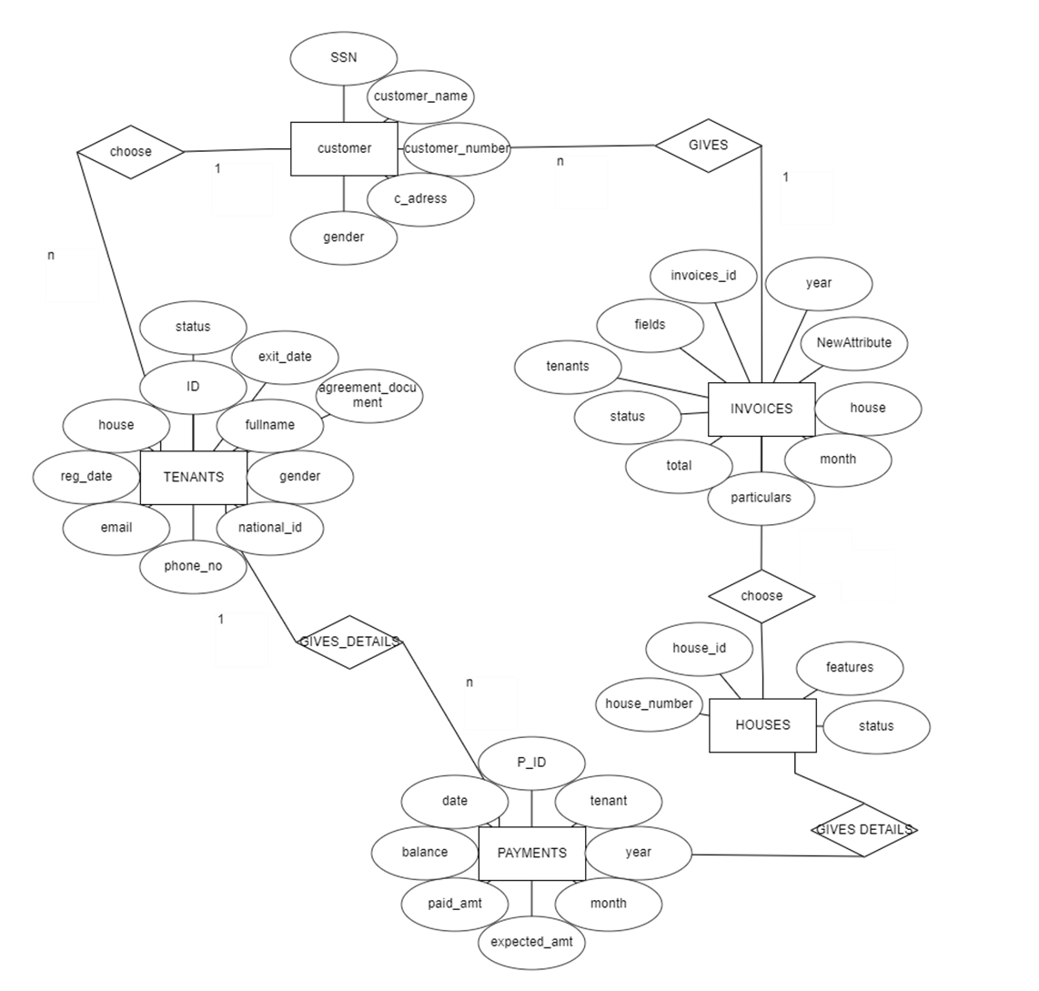

***Table : Food***

* + 1. **Database Schema**

##### Database:

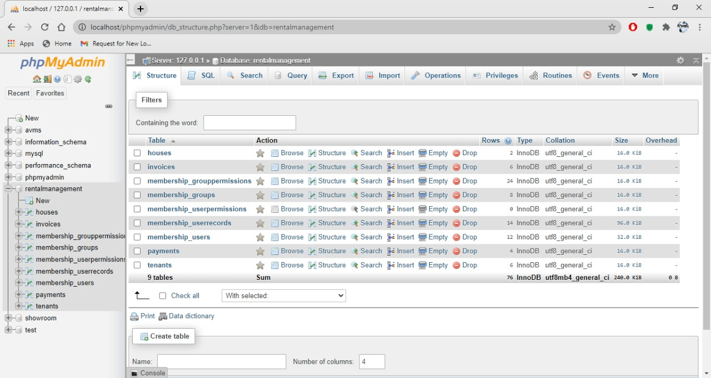

***Table:Houses***

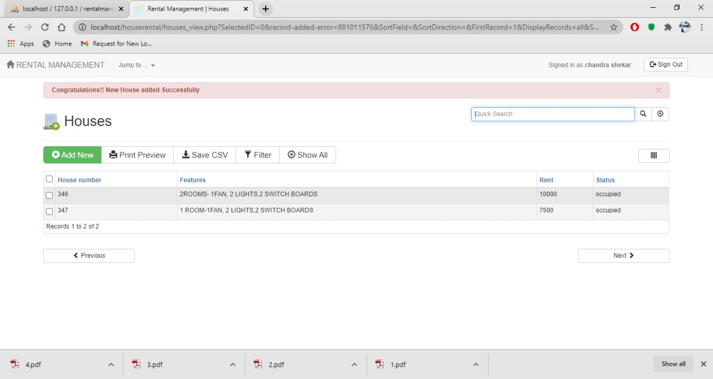

***Table: INVOICES***

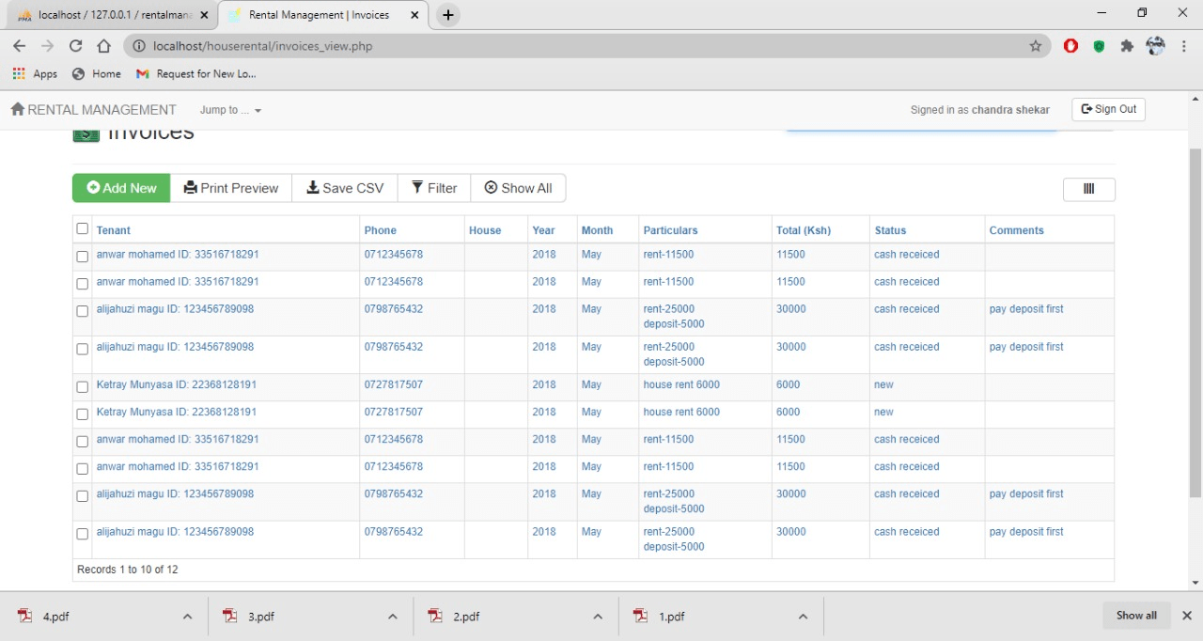

***Table: Tenant***

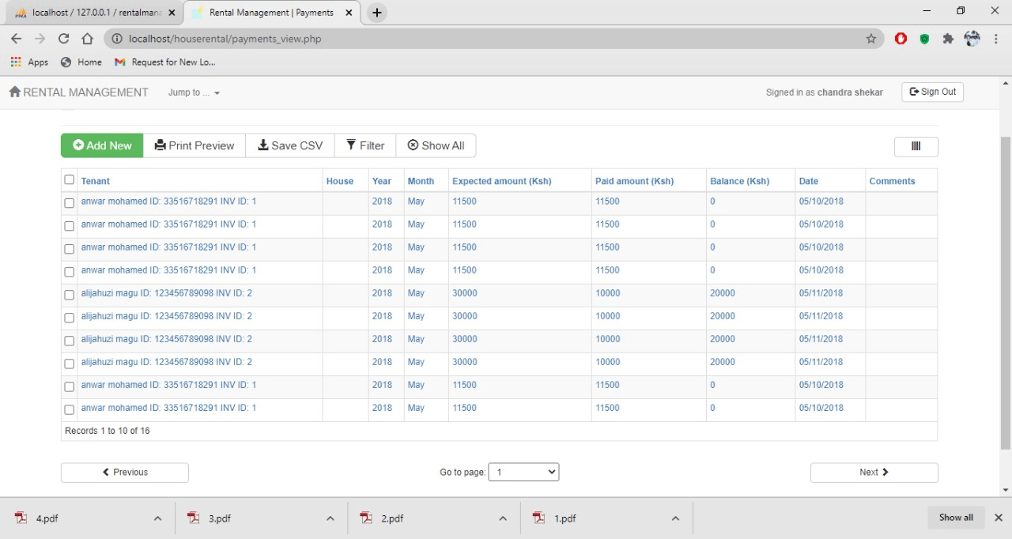



* + 1. ***Relational schema***

***Database:***

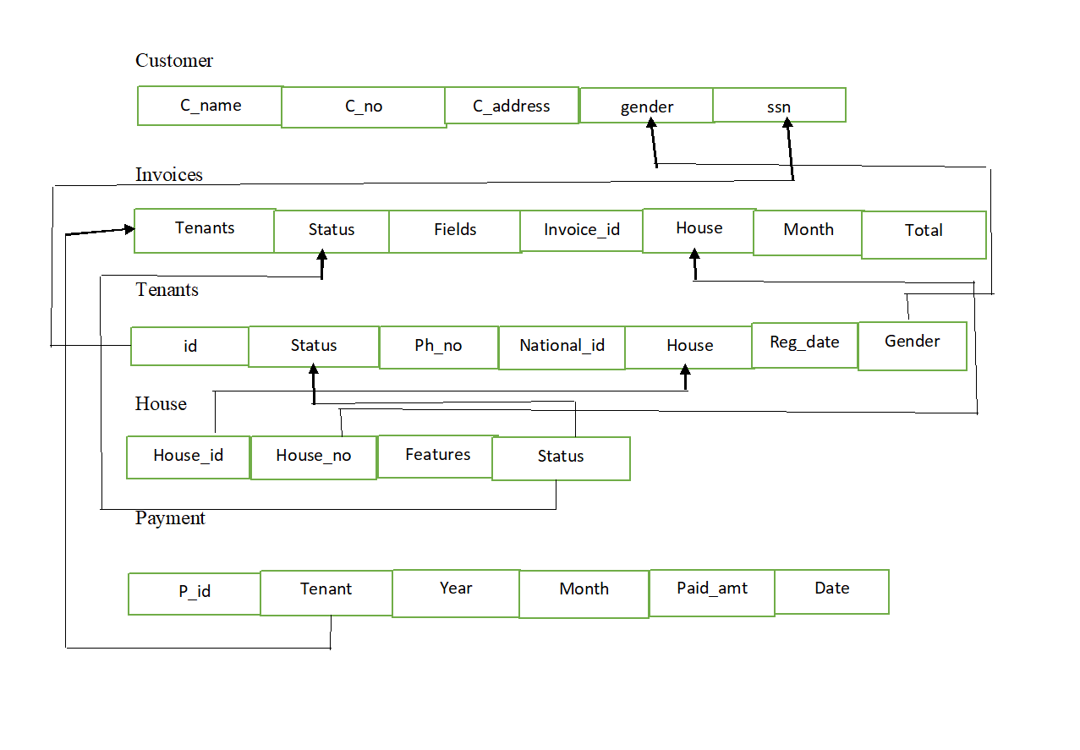

**Database Normalization**

* + 1. **First Normal Form**

All the Relations are designed in such a way that it has no repeating groups. Hence all tables are in 1st Normal Form.

### Second Normal Form

A relation is said to be in second normal form if it is already in first normal form and it has no partial dependency. All the tables in the database are designed in such a way that there is no partial dependency. Hence all tables are in 2nd Normal Form.

### Third Normal Form

A relation is said to be in third normal form if it is already in 1st and 2nd Normal Form and has no transitive dependency. All the tables in the database are designed in such a way that there is no transitive dependency. Hence all tables are in 3rd Normal Norm.

## User Interface

The User Interface of the Complaint Management System (Post Complaint Freely) is divided into User Module - For the users registered to post complaints

Admin Module – For the admin/owner(users) of the CMS



### USER OPERATIONS MODULE User Login

## Dash board

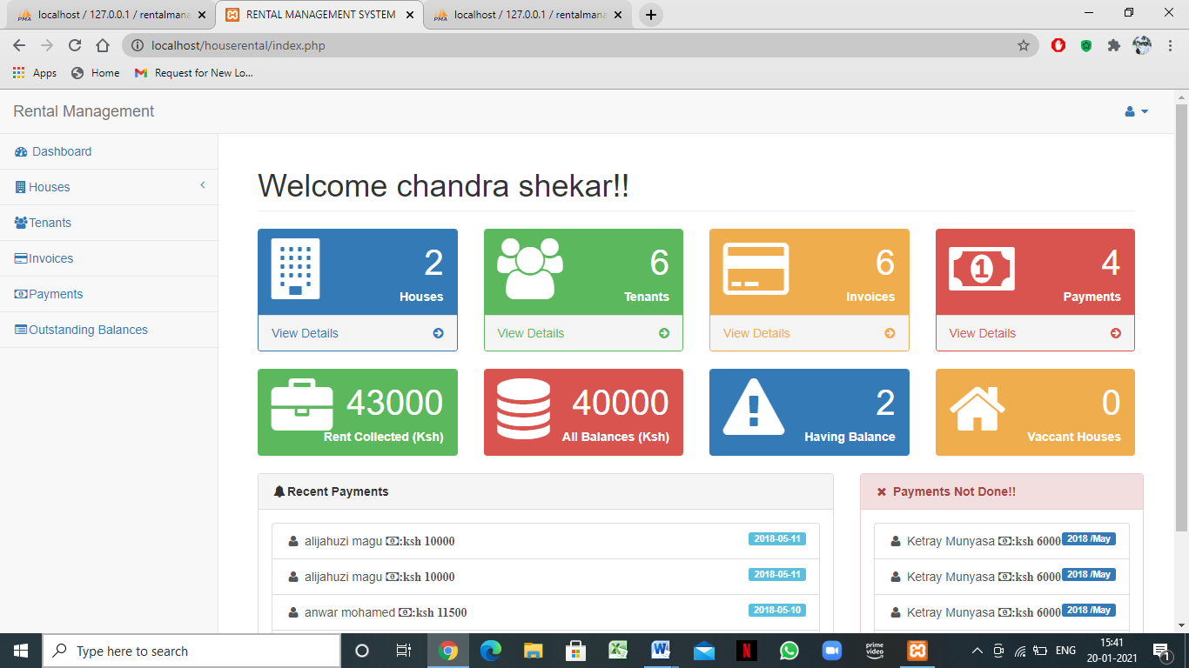

**Houses**

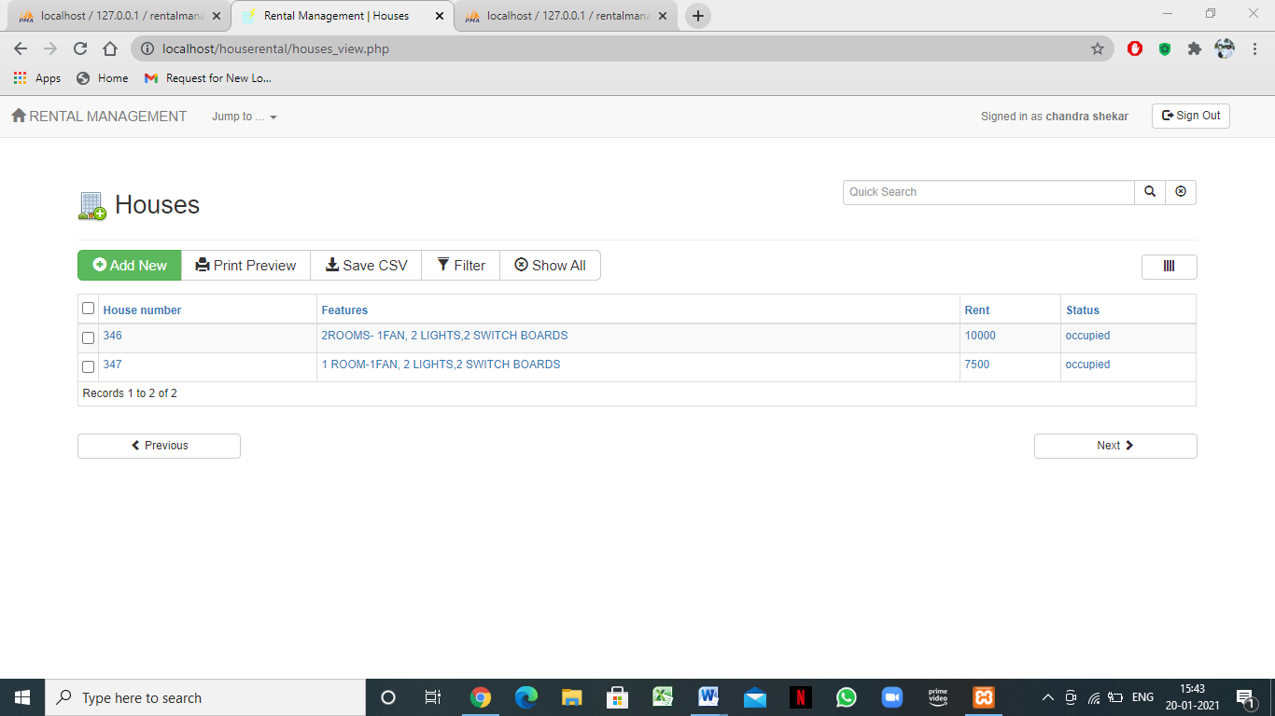

# Tenants

# 

# Invoices

# 

# Payments

# 

**STORED PROCEDURES :**

The stored procedure del implemented in project is for displaying the deleted orders of the users which shows all the information about the order like the order_date, number of items added to the order, the items added to the order etc.

**TRIGGERS :**

The trigger is implemented for inserting all details in the order table to a backup table order_ele which helps in having a backup of all the deleted orders by users.

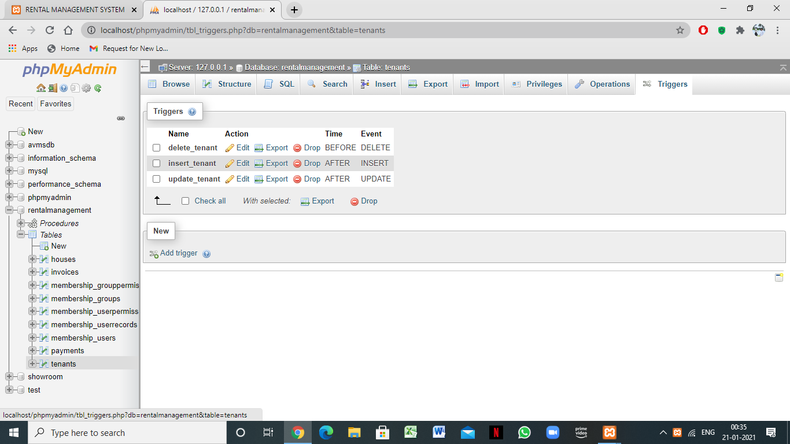



## SOURCE CODE

-- phpMyAdmin SQL Dump

-- version 4.2.11

-- http://www.phpmyadmin.net

--

-- Host: 127.0.0.1

-- Generation Time: Jun 05, 2019 at 05:02 PM

-- Server version: 5.6.21

-- PHP Version: 5.6.3

SET SQL_MODE = "NO_AUTO_VALUE_ON_ZERO";

SET time_zone = "+00:00";

/*!40101 SET @OLD_CHARACTER_SET_CLIENT=@@CHARACTER_SET_CLIENT */;

/*!40101 SET @OLD_CHARACTER_SET_RESULTS=@@CHARACTER_SET_RESULTS */;

/*!40101 SET @OLD_COLLATION_CONNECTION=@@COLLATION_CONNECTION */;

/*!40101 SET NAMES utf8 */;

--

-- Database: `rentalmanagement`

--

-- --------------------------------------------------------

--

-- Table structure for table `houses`

--

CREATE TABLE IF NOT EXISTS `houses` (

`id` int(10) unsigned NOT NULL,

`house_number` varchar(40) NOT NULL,

`features` text NOT NULL,

`rent` varchar(40) NOT NULL,

`status` varchar(40) NOT NULL

) ENGINE=InnoDB AUTO_INCREMENT=6 DEFAULT CHARSET=utf8;

--

-- Dumping data for table `houses`

--

INSERT INTO `houses` (`id`, `house_number`, `features`, `rent`, `status`) VALUES

(1, 'A20', 'bathroom,2 bedroom,kitchen ,water,shower', '11500', 'occupied'),

(2, 'A21', '3 bedroom,swimming pool,bathtub,hot water,kitchen', '25000', 'occupied'),

(3, 'A22', 'bedsitter', '6000', 'occupied'),

(4, 'NB135', 'Nine-foot ceilings, southern exposure, outdoor living spaces, maximized insulation', '7500', 'vaccant'),

(5, 'A20', 'demo', '6500', 'vaccant');

-- --------------------------------------------------------

--

-- Table structure for table `invoices`

--

CREATE TABLE IF NOT EXISTS `invoices` (

`id` int(10) unsigned NOT NULL,

`tenant` int(10) unsigned NOT NULL,

`phone` int(10) unsigned DEFAULT NULL,

`house` int(10) unsigned DEFAULT NULL,

`year` varchar(40) NOT NULL,

`month` varchar(40) NOT NULL,

`particulars` text NOT NULL,

`total` varchar(40) NOT NULL,

`comments` text,

`status` varchar(40) NOT NULL,

`field10` varchar(40) DEFAULT NULL

) ENGINE=InnoDB AUTO_INCREMENT=4 DEFAULT CHARSET=utf8;

--

-- Dumping data for table `invoices`

--

INSERT INTO `invoices` (`id`, `tenant`, `phone`, `house`, `year`, `month`, `particulars`, `total`, `comments`, `status`, `field10`) VALUES

(1, 1, 1, 1, '2018', 'May', 'rent-11500', '11500', '<br>', 'cash receiced', NULL),

(2, 2, 2, 2, '2018', 'May', 'rent-25000<div>deposit-5000</div>', '30000', 'pay deposit first', 'cash receiced', NULL),

(3, 3, 3, 3, '2018', 'May', 'house rent 6000', '6000', '<br>', 'new', NULL);

-- --------------------------------------------------------

--

-- Table structure for table `membership_grouppermissions`

--

CREATE TABLE IF NOT EXISTS `membership_grouppermissions` (

`permissionID` int(10) unsigned NOT NULL,

`groupID` int(11) DEFAULT NULL,

`tableName` varchar(100) DEFAULT NULL,

`allowInsert` tinyint(4) DEFAULT NULL,

`allowView` tinyint(4) NOT NULL DEFAULT '0',

`allowEdit` tinyint(4) NOT NULL DEFAULT '0',

`allowDelete` tinyint(4) NOT NULL DEFAULT '0'

) ENGINE=InnoDB AUTO_INCREMENT=25 DEFAULT CHARSET=utf8;

--

-- Dumping data for table `membership_grouppermissions`

--

INSERT INTO `membership_grouppermissions` (`permissionID`, `groupID`, `tableName`, `allowInsert`, `allowView`, `allowEdit`, `allowDelete`) VALUES

(1, 2, 'houses', 1, 3, 3, 3),

(2, 2, 'tenants', 1, 3, 3, 3),

(3, 2, 'invoices', 1, 3, 3, 3),

(4, 2, 'payments', 1, 3, 3, 3),

(13, 3, 'houses', 0, 3, 0, 0),

(14, 3, 'tenants', 0, 1, 0, 0),

(15, 3, 'invoices', 0, 1, 0, 0),

(16, 3, 'payments', 0, 1, 0, 0),

(21, 4, 'houses', 1, 3, 1, 1),

(22, 4, 'tenants', 1, 3, 1, 1),

(23, 4, 'invoices', 1, 3, 1, 1),

(24, 4, 'payments', 1, 3, 1, 1);

-- --------------------------------------------------------

--

-- Table structure for table `membership_groups`

--

CREATE TABLE IF NOT EXISTS `membership_groups` (

`groupID` int(10) unsigned NOT NULL,

`name` varchar(20) DEFAULT NULL,

`description` text,

`allowSignup` tinyint(4) DEFAULT NULL,

`needsApproval` tinyint(4) DEFAULT NULL

) ENGINE=InnoDB AUTO_INCREMENT=5 DEFAULT CHARSET=utf8;

--

-- Dumping data for table `membership_groups`

--

INSERT INTO `membership_groups` (`groupID`, `name`, `description`, `allowSignup`, `needsApproval`) VALUES

(1, 'anonymous', 'Anonymous group created automatically on 2018-05-10', 0, 0),

(2, 'Admins', 'Admin group created automatically on 2018-05-10', 0, 1),

(3, 'tenants', 'tenants here', 0, 1),

(4, 'users', 'all test users', 1, 0);

-- --------------------------------------------------------

--

-- Table structure for table `membership_userpermissions`

--

CREATE TABLE IF NOT EXISTS `membership_userpermissions` (

`permissionID` int(10) unsigned NOT NULL,

`memberID` varchar(20) NOT NULL,

`tableName` varchar(100) DEFAULT NULL,

`allowInsert` tinyint(4) DEFAULT NULL,

`allowView` tinyint(4) NOT NULL DEFAULT '0',

`allowEdit` tinyint(4) NOT NULL DEFAULT '0',

`allowDelete` tinyint(4) NOT NULL DEFAULT '0'

) ENGINE=InnoDB DEFAULT CHARSET=utf8;

-- --------------------------------------------------------

--

-- Table structure for table `membership_userrecords`

--

CREATE TABLE IF NOT EXISTS `membership_userrecords` (

`recID` bigint(20) unsigned NOT NULL,

`tableName` varchar(100) DEFAULT NULL,

`pkValue` varchar(255) DEFAULT NULL,

`memberID` varchar(20) DEFAULT NULL,

`dateAdded` bigint(20) unsigned DEFAULT NULL,

`dateUpdated` bigint(20) unsigned DEFAULT NULL,

`groupID` int(11) DEFAULT NULL

) ENGINE=InnoDB AUTO_INCREMENT=15 DEFAULT CHARSET=utf8;

--

-- Dumping data for table `membership_userrecords`

--

INSERT INTO `membership_userrecords` (`recID`, `tableName`, `pkValue`, `memberID`, `dateAdded`, `dateUpdated`, `groupID`) VALUES

(1, 'houses', '1', 'admin', 1525967004, 1525970651, 2),

(2, 'tenants', '1', 'alijahuzi', 1525967170, 1526056194, 3),

(3, 'invoices', '1', 'alijahuzi', 1525967307, 1526147635, 3),

(5, 'payments', '2', 'alijahuzi', 1525969044, 1526056845, 3),

(6, 'houses', '2', 'admin', 1526081667, 1526081746, 2),

(7, 'tenants', '2', 'admin', 1526081759, 1526081759, 2),

(8, 'invoices', '2', 'admin', 1526081858, 1526147664, 2),

(9, 'payments', '3', 'admin', 1526088996, 1526088996, 2),

(10, 'houses', '3', 'admin', 1526089077, 1526089406, 2),

(11, 'tenants', '3', 'admin', 1526089430, 1526089450, 2),

(12, 'invoices', '3', 'admin', 1526089653, 1526147690, 2),

(13, 'houses', '4', 'harry', 1532236592, 1532236592, 4),

(14, 'houses', '5', 'harry', 1537193426, 1537193426, 4);

-- --------------------------------------------------------

--

-- Table structure for table `membership_users`

--

CREATE TABLE IF NOT EXISTS `membership_users` (

`memberID` varchar(20) NOT NULL,

`passMD5` varchar(40) DEFAULT NULL,

`email` varchar(100) DEFAULT NULL,

`signupDate` date DEFAULT NULL,

`groupID` int(10) unsigned DEFAULT NULL,

`isBanned` tinyint(4) DEFAULT NULL,

`isApproved` tinyint(4) DEFAULT NULL,

`custom1` text,

`custom2` text,

`custom3` text,

`custom4` text,

`comments` text,

`pass_reset_key` varchar(100) DEFAULT NULL,

`pass_reset_expiry` int(10) unsigned DEFAULT NULL

) ENGINE=InnoDB DEFAULT CHARSET=utf8;

--

-- Dumping data for table `membership_users`

--

INSERT INTO `membership_users` (`memberID`, `passMD5`, `email`, `signupDate`, `groupID`, `isBanned`, `isApproved`, `custom1`, `custom2`, `custom3`, `custom4`, `comments`, `pass_reset_key`, `pass_reset_expiry`) VALUES

('admin', 'admin', 'admin@admin.com', '2018-05-10', 2, 0, 1, NULL, NULL, NULL, NULL, 'Admin member created automatically on 2018-05-10\nRecord updated automatically on 2018-05-10\nRecord updated automatically on 2018-05-12\nRecord updated automatically on 2018-05-13', NULL, NULL),

('alijahuzi', '827ccb0eea8a706c4c34a16891f84e7b', 'ali@gmail.com', '2018-05-10', 3, 0, 1, '', '', '', '', 'member signed up through the registration form.', NULL, NULL),

('brandy', '6c29e9cc4042d972b15ff0304e636886', 'brandy@gmail.com', '2018-05-13', 4, 0, 1, '', '', '', '', 'member signed up through the registration form.', NULL, NULL),

('guest', NULL, NULL, '2018-05-10', 1, 0, 1, NULL, NULL, NULL, NULL, 'Anonymous member created automatically on 2018-05-10', NULL, NULL),

('harry', 'd3915844cde56f2dccfd24c7d34d12f0', 'harry@den.com', '2018-05-18', 4, 0, 1, '', '', '', '', 'member signed up through the registration form.', NULL, NULL);

-- --------------------------------------------------------

--

-- Table structure for table `payments`

--

CREATE TABLE IF NOT EXISTS `payments` (

`id` int(10) unsigned NOT NULL,

`tenant` int(10) unsigned NOT NULL,

`house` int(10) unsigned DEFAULT NULL,

`year` int(10) unsigned DEFAULT NULL,

`month` int(10) unsigned DEFAULT NULL,

`expected_amount` int(10) unsigned DEFAULT NULL,

`paid_amount` varchar(40) NOT NULL,

`balance` varchar(40) DEFAULT NULL,

`date` date NOT NULL,

 `comments` text

) ENGINE=InnoDB AUTO_INCREMENT=4 DEFAULT CHARSET=utf8;

--

-- Dumping data for table `payments`

--

INSERT INTO `payments` (`id`, `tenant`, `house`, `year`, `month`, `expected_amount`, `paid_amount`, `balance`, `date`, `comments`) VALUES

(2, 1, 1, 1, 1, 1, '11500', '0', '2018-05-10', '<br>'),

(3, 2, 2, 2, 2, 2, '10000', '20000', '2018-05-11', '<br>');

-- --------------------------------------------------------

--

-- Table structure for table `tenants`

--

CREATE TABLE IF NOT EXISTS `tenants` (

`id` int(10) unsigned NOT NULL,

`fullname` varchar(40) NOT NULL,

`gender` varchar(40) NOT NULL,

`national_id` varchar(40) NOT NULL,

`phone_number` varchar(40) NOT NULL,

`email` varchar(80) DEFAULT NULL,

`registration_date` date NOT NULL,

`house` int(10) unsigned NOT NULL,

`status` varchar(40) NOT NULL,

`exit_date` date DEFAULT NULL,

`agreement_document` varchar(100) DEFAULT NULL

) ENGINE=InnoDB AUTO_INCREMENT=4 DEFAULT CHARSET=utf8;

--

-- Dumping data for table `tenants`

--

INSERT INTO `tenants` (`id`, `fullname`, `gender`, `national_id`, `phone_number`, `email`, `registration_date`, `house`, `status`, `exit_date`, `agreement_document`) VALUES

(1, 'anwar mohamed', 'male', '33516718291', '0712345678', 'anwarmoha@gmail.com', '2018-05-10', 1, 'tenant in', NULL, '3e92349ecb4d1781a.pdf'),

(2, 'alijahuzi magu', 'male', '123456789098', '0798765432', 'ali@gmail.com', '2018-05-11', 2, 'tenant in', NULL, NULL),

 (3, 'Ketray Munyasa', 'female', '22368128191', '0727817507', 'ketmunyasa@gmail.com', '2018-05-11', 3, 'tenant in', NULL, '3279aaea4aabfa662.pdf');

--

-- Indexes for dumped tables

--

--

-- Indexes for table `houses`

--

ALTER TABLE `houses`

ADD PRIMARY KEY (`id`);

--

-- Indexes for table `invoices`

--

ALTER TABLE `invoices`

ADD PRIMARY KEY (`id`), ADD KEY `tenant` (`tenant`);

--

-- Indexes for table `membership_grouppermissions`

--

ALTER TABLE `membership_grouppermissions`

ADD PRIMARY KEY (`permissionID`);

--

-- Indexes for table `membership_groups`

--

ALTER TABLE `membership_groups`

ADD PRIMARY KEY (`groupID`);

--

-- Indexes for table `membership_userpermissions`

--

ALTER TABLE `membership_userpermissions`

ADD PRIMARY KEY (`permissionID`);

--

-- Indexes for table `membership_userrecords`

--

ALTER TABLE `membership_userrecords`

ADD PRIMARY KEY (`recID`), ADD UNIQUE KEY `tableName_pkValue` (`tableName`,`pkValue`), ADD KEY `pkValue` (`pkValue`), ADD KEY `tableName` (`tableName`), ADD KEY `memberID` (`memberID`), ADD KEY `groupID` (`groupID`);

--

-- Indexes for table `membership_users`

--

ALTER TABLE `membership_users`

ADD PRIMARY KEY (`memberID`), ADD KEY `groupID` (`groupID`);

--

-- Indexes for table `payments`

--

ALTER TABLE `payments`

ADD PRIMARY KEY (`id`), ADD KEY `tenant` (`tenant`);

--

-- Indexes for table `tenants`

--

ALTER TABLE `tenants`

ADD PRIMARY KEY (`id`), ADD KEY `house` (`house`);

--

-- AUTO_INCREMENT for dumped tables

--

--

-- AUTO_INCREMENT for table `houses`

--

ALTER TABLE `houses`

MODIFY `id` int(10) unsigned NOT NULL AUTO_INCREMENT,AUTO_INCREMENT=6;

--

-- AUTO_INCREMENT for table `invoices`

--

ALTER TABLE `invoices`

MODIFY `id` int(10) unsigned NOT NULL AUTO_INCREMENT,AUTO_INCREMENT=4;

--

-- AUTO_INCREMENT for table `membership_grouppermissions`

--

ALTER TABLE `membership_grouppermissions`

MODIFY `permissionID` int(10) unsigned NOT NULL AUTO_INCREMENT,AUTO_INCREMENT=25;

--

-- AUTO_INCREMENT for table `membership_groups`

--

ALTER TABLE `membership_groups`

MODIFY `groupID` int(10) unsigned NOT NULL AUTO_INCREMENT,AUTO_INCREMENT=5;

--

-- AUTO_INCREMENT for table `membership_userpermissions`

--

ALTER TABLE `membership_userpermissions`

MODIFY `permissionID` int(10) unsigned NOT NULL AUTO_INCREMENT;

--

-- AUTO_INCREMENT for table `membership_userrecords`

--

ALTER TABLE `membership_userrecords`

MODIFY `recID` bigint(20) unsigned NOT NULL AUTO_INCREMENT,AUTO_INCREMENT=15;

--

-- AUTO_INCREMENT for table `payments`

--

ALTER TABLE `payments`

MODIFY `id` int(10) unsigned NOT NULL AUTO_INCREMENT,AUTO_INCREMENT=4;

--

-- AUTO_INCREMENT for table `tenants`

--

ALTER TABLE `tenants`

MODIFY `id` int(10) unsigned NOT NULL AUTO_INCREMENT,AUTO_INCREMENT=4;

/*!40101 SET CHARACTER_SET_CLIENT=@OLD_CHARACTER_SET_CLIENT */;

/*!40101 SET CHARACTER_SET_RESULTS=@OLD_CHARACTER_SET_RESULTS */;

/*!40101 SET COLLATION_CONNECTION=@OLD_COLLATION_CONNECTION */;

## BIBLIOGRAPHY

**BOOK REFERENCES:**

1. Learn to Code HTML and CSS: Develop and Style Websites (Web Design Courses) 1st,

Kindle Edition by Shay Howe

1. *PHP 6 and MySQL 5* - Larry Ullman

**WEBSITE REFERENCES:**

**HTML Learning:**

1. <https://www.codecademy.com/>

1. <https://dash.generalassemb.ly/>

1. <https://www.w3schools.com/>

**PHP Learning:**

1. http://www.tutorialspoint.com/php/

2.[https://killerphp.com](https://killerphp.com/)

# CONCLUSIONS

The backend-portal is enables its users to access, manage and update student’s data effectively

and efficiently. It allows for a centralized facility that can easily be modified and quickly shared among multiple users. The backend-portal eliminates the paper work which could lead to loss of data and data redundancy. It also allows the possibility of queries to obtain information for various surveys. Due to the many users reading and modifying student data in the department, Hence it is an ideal use for such a system.

Dept. of CSE, DSATM 2019-20 Page 27